Provenience (Pb Isotopes)

We were given data regarding different Pb-isotope ratios in three different countries which helped in determining the source of different materials excavated from one site. By comparing the source of raw materials, we can make observations about social networks during the time and how elites influenced trade routes over two different periods.

1. The following Pb-isotope ratio pair is the one that separated the ore sources best for me

* It was difficult to find sets where there was a distinct grouping of ratios according to country, so finding scatter plots that abided by the provenience postulate was difficult. Ultimately, I had to visually decide which of the plots had origin defining groups with the least chemical difference. The only plot that seemed to follow the postulate was the plot of “206Pb/204Pb vs 207Pb/204Pb”. For all countries,

$distance across groupings<distance between groupings$

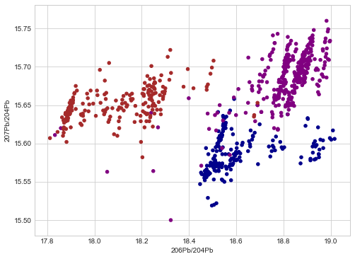

**Cyprus**

**Sardinia**

**Greece**

1. Upon initial examination, there is no definitive observable difference between the ratios of Pb isotopes in different periods visually. However, the scatter plots from Period 1 do seem to be ‘shifted down’, and possibly even ‘shifted left’, resulting in the points for Period 2. Hence, we can generalize a decrease in Pb-207, Pb-208, and Pb-206 isotopes since Pb-204 is more or less constant. Our generalization can be confirmed by calculating the differences in mean between different periods.

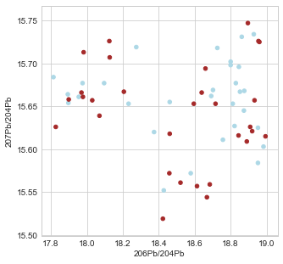

**Period 1**

**Period 2**

The very miniscule difference in mean values, where Period 1 > Period 2

208Pb/206Pb 207Pb/206Pb 206Pb/204Pb 207Pb/204Pb

Period

1 2.085033 0.843567 18.568200 15.658600

2 2.082033 0.845967 18.498467 15.641933

When we begin to compare the materials obtained by a workshop between two time periods, we begin noticing a difference in the composition of the raw materials.

For the workshop located at A1,

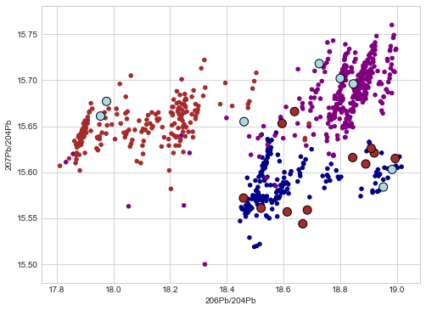

**Period 1**

**Period 2**

**Cyprus**

**Sardinia**

**Greece**

We can see that during period 1, the ratio values correspond to the composition of the materials found at Sardinia and Greece, however, during period 2, the materials only seem to be from Cyprus, excepting a couple of outliers.

For the workshop at B2,

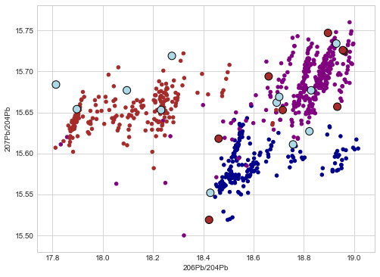

**Period 1**

**Period 2**

**Cyprus**

**Sardinia**

**Greece**

During period 1, excluding a couple of outliers, the materials seem to only be from Greece and Sardinia, but the raw materials obtained during period 2 originate from Cyprus and Greece.

Similarly, for the workshop at C4,

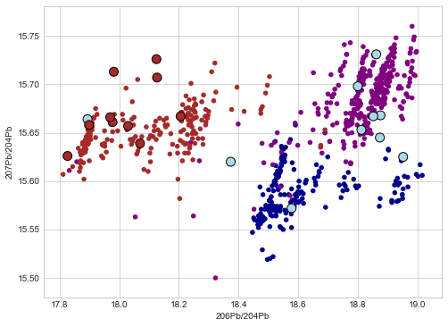

**Period 1**

**Period 2**

**Cyprus**

**Sardinia**

**Greece**

During period 1, the materials are from Greece and Cyprus and during period 2, the metals are exclusively from Sardinia.

1. We see in our observations that during different periods, the materials obtained originated from different places, signaling some sort of influence over trade routes.

During period 1, a lot of the raw materials obtained for making these artifacts were imported from Sardinia and Greece. However, during period 2, we can see Sardinia being excluded from workshops B2 and C4, which may tell us that there was something that impacted the relationship between our site and the country. In workshop C4, Sardinia is the only country that the raw materials are coming from. This may also indicate a preference of a certain material for decorations since that was what the majority of the artifacts from C4 were classified as. Since it also crafted only decorative pieces, we may also assume a lack of control by the elites just for that workshop since it is so different from the other ones.

1. The only problem I encountered while making observations was deciding on which points on the scatter plots were to be classified as outliers. Another problem was deciding on which ratio plot to choose as my base, since all the plots had more or less the same uncertainty when it came to differentiating location by country.